**DS160- Analyzing the data using Excel**

**File- Option-Addins- Excel Addins – go-select analysis tool pack**

**Task 1: Calculate Basic Descriptive Measures**

1. **Mean: Calculate the mean (average) of the Murder, Assault, and Urban Pop**
2. **Median: Calculate the median (middle value) of the Murder, Assault, and Urban Pop**
3. **Standard Deviation: Calculate the standard deviation of the Murder, Assault, and Urban Pop**
4. **Minimum and Maximum: Find the minimum and maximum Murder, Assault, and Urban Pop**
5. **Calculate the Interquartile Range (IQR)**

|  |  |  |  |  |  |
| --- | --- | --- | --- | --- | --- |
| *Task 1* | | | | | |
| *Murder* |  | *Assault* |  | *UrbanPop* |  |
|  |  |  |  |  |  |
| Mean | 7.681636 | Mean | 182.1837 | Mean | 64.08163 |
| Standard Error | 0.609564 | Standard Error | 18.31902 | Standard Error | 2.322531 |
| Median | 7.040909 | Median | 159 | Median | 66 |
| Mode | 13.2 | Mode | 120 | Mode | 80 |
| Standard Deviation | 4.310269 | Standard Deviation | 129.5351 | Standard Deviation | 16.42278 |
| Sample Variance | 18.57842 | Sample Variance | 16779.33 | Sample Variance | 269.7076 |
| Range | 16.6 | Range | 834 | Range | 85 |
| Minimum | 0.8 | Minimum | 45 | Minimum | 6 |
| Maximum | 17.4 | Maximum | 879 | Maximum | 91 |
| Sum | 384.0818 | Sum | 9109.184 | Sum | 3204.082 |
| Count | 50 | Count | 50 | Count | 50 |
| IQR | 6.85 | IQR | 140 |  | 23.25 |

**Murder: the mean is 7.68, median is 7.04, mode is 13.2, standard deviation is 4.31, variance, range, IQR, also shown in table 1**

**Task2: Data Representation (Histogram, Scatterplot)**

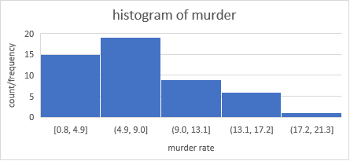

**Task3: Types of variables (Numerical/categorical/ Ratio/ Interval)**

**State is categorical while murder assault, and urban population are all numerical**

**(is murder and assault dependent on the urban population)**

**Murder: ratio**

**Assault: ratio**

**Urban population: ratio**

**Task4: Diagnostic Analysis**

**Explain the correlation(task to do)**

|  |  |  |  |
| --- | --- | --- | --- |
|  | *Murder* | *Assault* | *UrbanPop* |
| Murder | 1 |  |  |
| Assault | 0.642621 | 1 |  |
| UrbanPop | -0.05177 | -0.01633 | 1 |

**Murder and assault are strongly positively correlated. (> 0.5). if the murder rate increases in a city, the assault rate will also increase**

**Murder and assault have a weak negative correlation with urban population. If the murder rate or assault rate increases, the urban population decreases.**

**Task5: Interpret the Results**

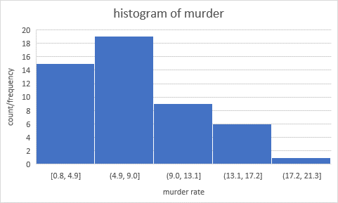

**Top of Form**